 



Database Programming with SQL 5-3: Conditional Expressions Practice Activities

# Objectives

* Compare and contrast the DECODE and CASE functions
* Construct and execute a SQL query that correctly uses the DECODE and CASE functions
* Construct and execute two methods for implementing IF-THEN-ELSE conditional logic

# Vocabulary

Identify the vocabulary word for each definition below.

|  |  |
| --- | --- |
| **DECODE** | Compares an expression to each of the search values |
| **conditional expression** | An if-then-else expression whose value depends on the truth- value of a Boolean expression. |
| **CASE** | Implements conditional processing within a SQL statement; it meets the ANSI standard. |

# Try It / Solve It

1. From the DJs on Demand d_songs table, create a query that replaces the 2-minute songs with “shortest” and the 10-minute songs with “longest”. Label the output column “Play Times”.

SELECT title,

CASE

WHEN TO_NUMBER(REPLACE(NVL(duration,'0 min'), ' min', '')) = 2 THEN 'Shortest'

WHEN TO_NUMBER(REPLACE(NVL(duration,'0 min'), ' min', '')) = 10 THEN 'Longest'

ELSE NVL(duration,'0 min')

END

as "Play Times"

FROM d_songs;

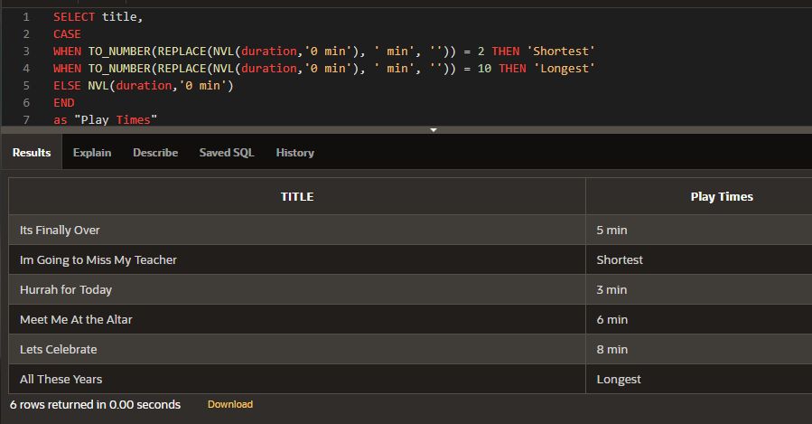

1. Use the Oracle database employees table and CASE expression to decode the department id. Display the department id, last name, salary, and a column called “New Salary” whose value is based on the following conditions:

If the department id is 10 then 1.25 * salary If the department id is 90 then 1.5 * salary

If the department id is 130 then 1.75 * salary Otherwise, display the old salary.

SELECT NVL(TO_CHAR(department_id), 'none') department_id , last_name, NVL(salary,0) salary,

CASE department_id

WHEN 10 THEN 1.25*NVL(salary,0)

WHEN 90 THEN 1.5*NVL(salary,0)

WHEN 130 THEN 1.75*NVL(salary,0)

ELSE NVL(salary,0)

END

as "New Salary"

FROM employees;

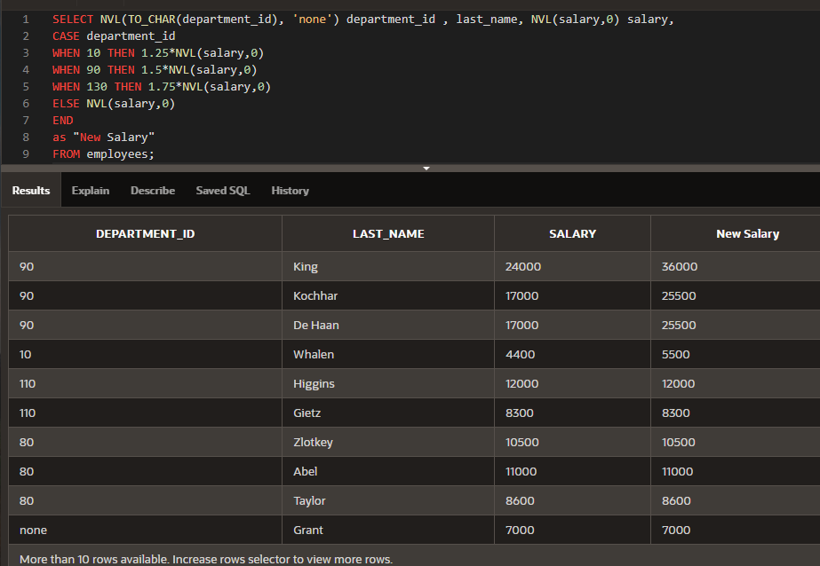

1. Display the first name, last name, manager ID, and commission percentage of all employees in departments 80 and 90. In a 5th column called “Review”, again display the manager ID. If they don’t have a manager, display the commission percentage. If they don’t have a commission, display 99999.

SELECT first_name, last_name, manager_id, commission_pct,

COALESCE(manager_id,commission_pct ,99999)

as "Review"

FROM employees

WHERE department_id in (80, 90);

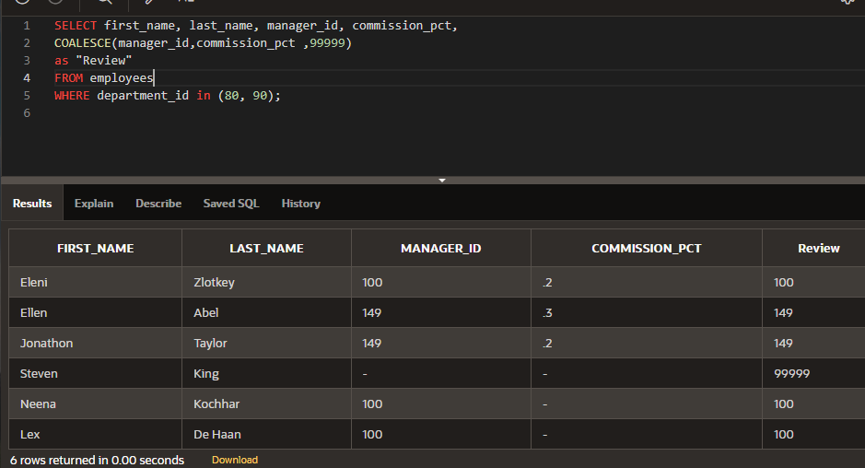

Copyright © 2020, Oracle and/or its affiliates. All rights reserved. Oracle and Java are registered trademarks of Oracle and/or its affiliates. Other names may be trademarks of their respective owners.